**Assisted Practice Project-1**

**Name-Kunal chakraborty**

//Implicit type casting

**package** demo;

**public** **class** implicittypecasting {

**public** **static** **void** main(String[] args) {

**char** a='b';

**int** v=a;

System.***out***.println(v);

}

}

**Output:**

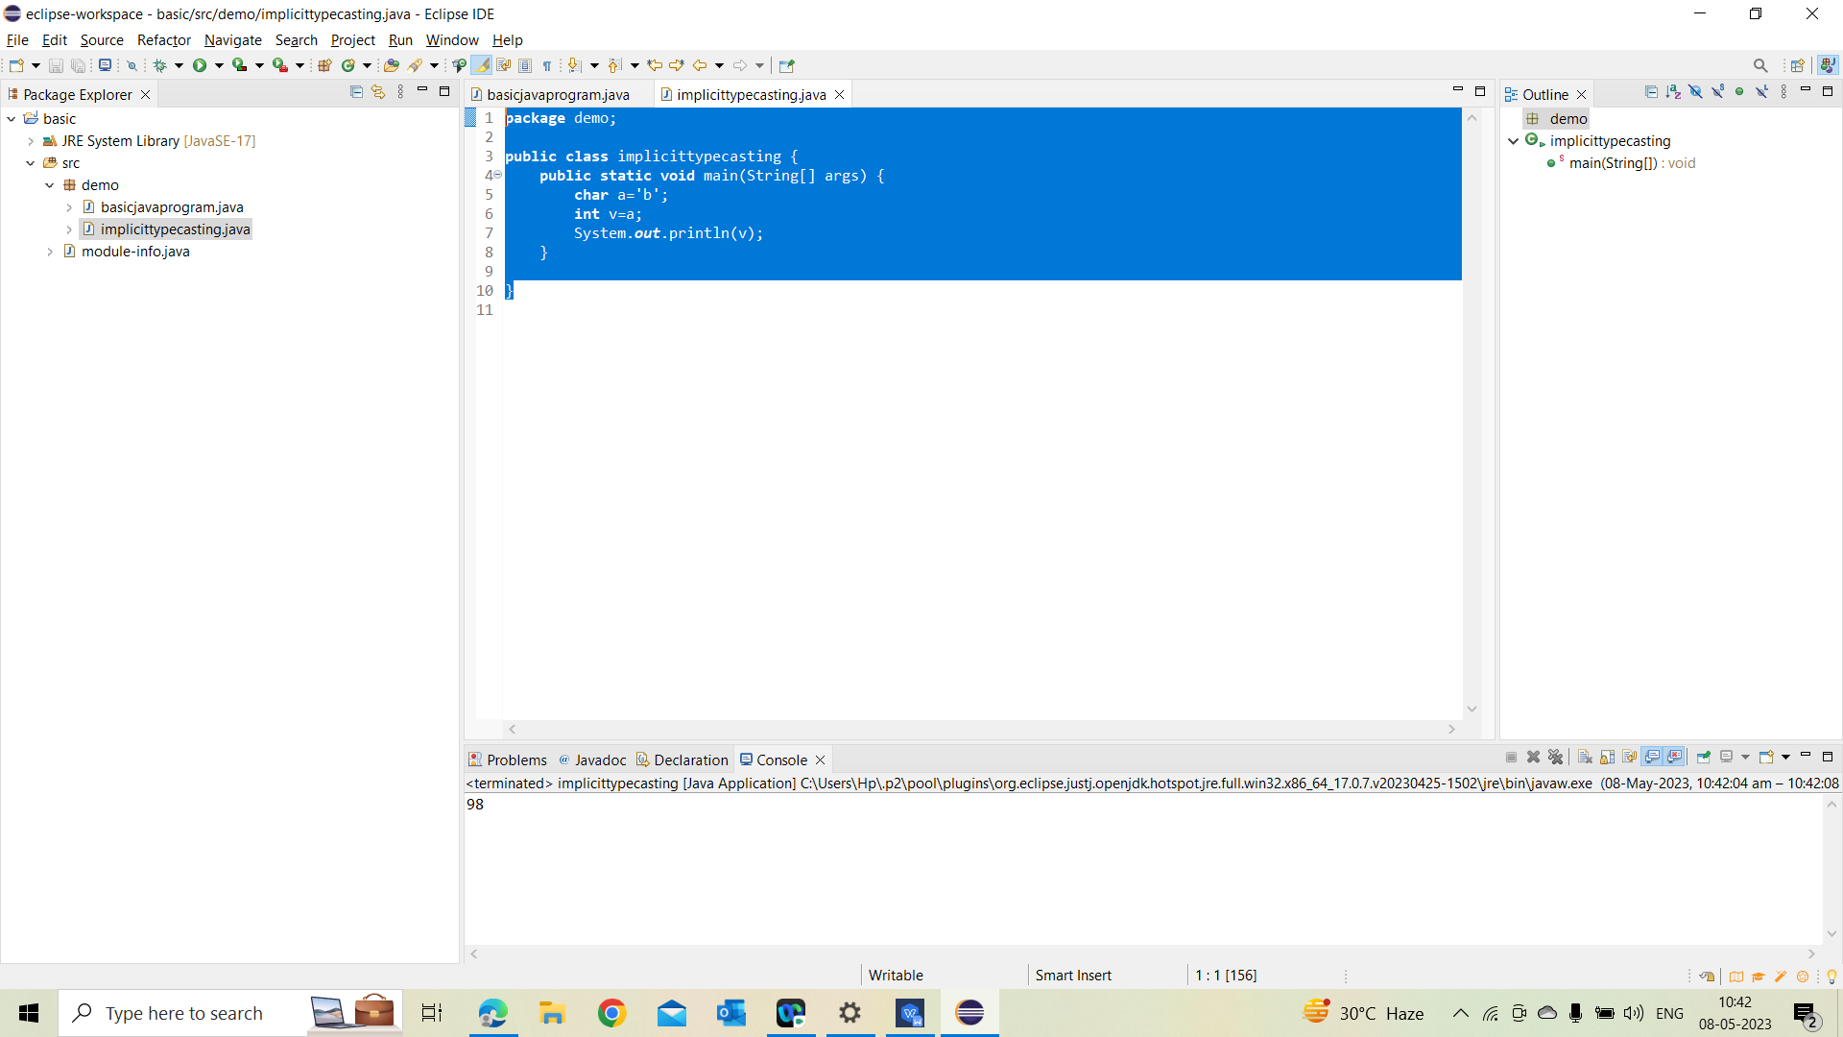

//Explicit type casting

**package** demo;

**public** **class** Explicittypecasting {

**public** **static** **void** main(String[] args) {

**int** a=70;

**char** v = (**char**) a;

System.***out***.println(v);

}

}

**Output:**

